School of Engineering

Christian Brothers University

Invoice and Inventory Management System – Project draft paper

The Engineering Management Capstone Project

Submitted in Partial Fulfillment for the Degree of Master of Science in Computer Information Systems

By:

**Mohammed Yaqoob**

**Bala Rama Krishna Peddi**

Memphis, Tennessee

February 20, 2023

* **Cover Page**
* **Acknowledgments**
* **Executive Summary**

1. Introduction
2. Objective
3. Project Description
4. Project Features
5. Technologies Used
6. System Design (Mockups)
7. Methodology Used
8. Output Screenshots
9. Project Deployment
10. Conclusion
11. References
12. **Introduction**

The project Invoice and Inventory Management System is a complete desktop desktop-based application designed on Java technology using Eclipse. The project's main aim is to develop Invoice and Inventory Management System Model software in which all the information regarding the organization's stock will be presented. It is an intranet-based desktop application with an admin component to manage the inventory and maintenance of the inventory system. This desktop application is based on an organization’s stock management. The application contains a general l organization profile, sales details, Purchase details, and the remaining stock that is presented in the organization. There is a provision for updating the inventory also. This application also provides the remaining balance of the stock. Each new stock is created and entitled with the name and the entry date of that stock, and it can also be updated at any time required as per the transaction. Here the login page is created to protect the management of the organization's stock in front of it from the threads and misuse of the inventory.

1. **Objective**

The main goal of this project is to consolidate all useful information related to billing and inventory management. Use HTML5, CSS3, Java, JavaScript, and MySQL to develop web applications that provide all the information you need about your invoices and inventory.

1. **Project Description**

The aim of the project is to develop a desktop-based application named Invoice and Inventory Management System for managing the inventory system of any organization. The Invoice and Inventory Management System (IIMS) refers to the system and processes to manage the stock of an organization with the involvement of a Technology system. This system can be used to store the details of the company inventory, stock maintenance, and update the inventory based on the sales details, and Stock and inventory report. This project is categorizing individual aspects of the sales and inventory management system. In this system, we are solving different problems affecting direct sales management and purchase management. An inventory Management System is important to ensure quality control in Real-world businesses that handle transactions revolving around consumer goods. Without proper inventory control, a large retail store may run out of stock on an important item. A good inventory management system will alert the wholesaler when it is time to record. An inventory Management System is also an important means of automatically tracking stock details. An automated Inventory Management System helps to minimize errors while recording the stock.

1. Project Features (As of now completed features)

* Login page for Admin
* Logout functionality
* Registration page for Users
* Login for Users
* View profiles for Users
* Change the password for Users.
* Logout functionality for Users
* Accept user requests by admin when creating a user.

1. Technologies Used

* JSP pages
* HTML
* CSS
* JavaScript
* MySQL

1. System Design (Mockups)

Login Page:

Registration Page:

1. Output Screenshots:

Home Page when the application is opened.

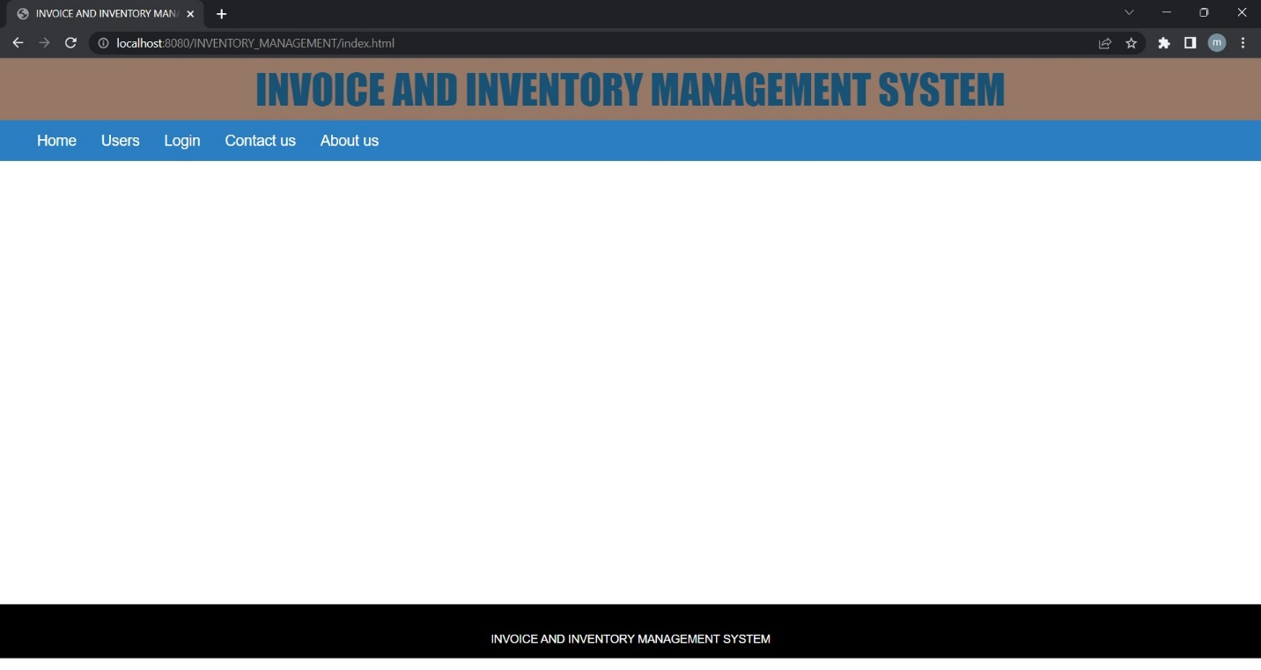

Login Page for Admin – Admin can log in with admin credentials by selecting admin on the front page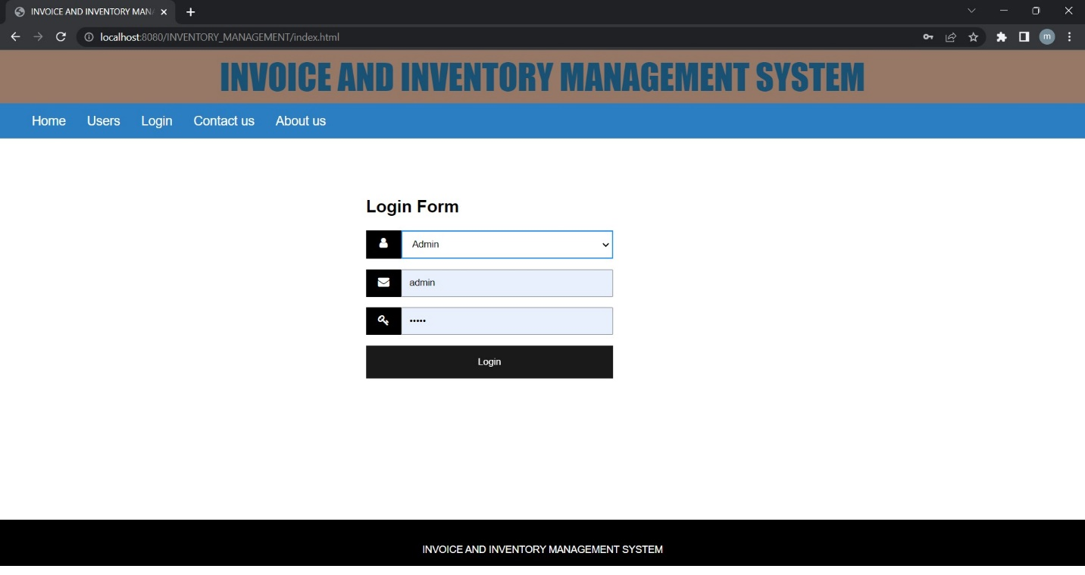

Navigation Bar for admin – After login in with admin we can see the navbar for admin and logout functionality.

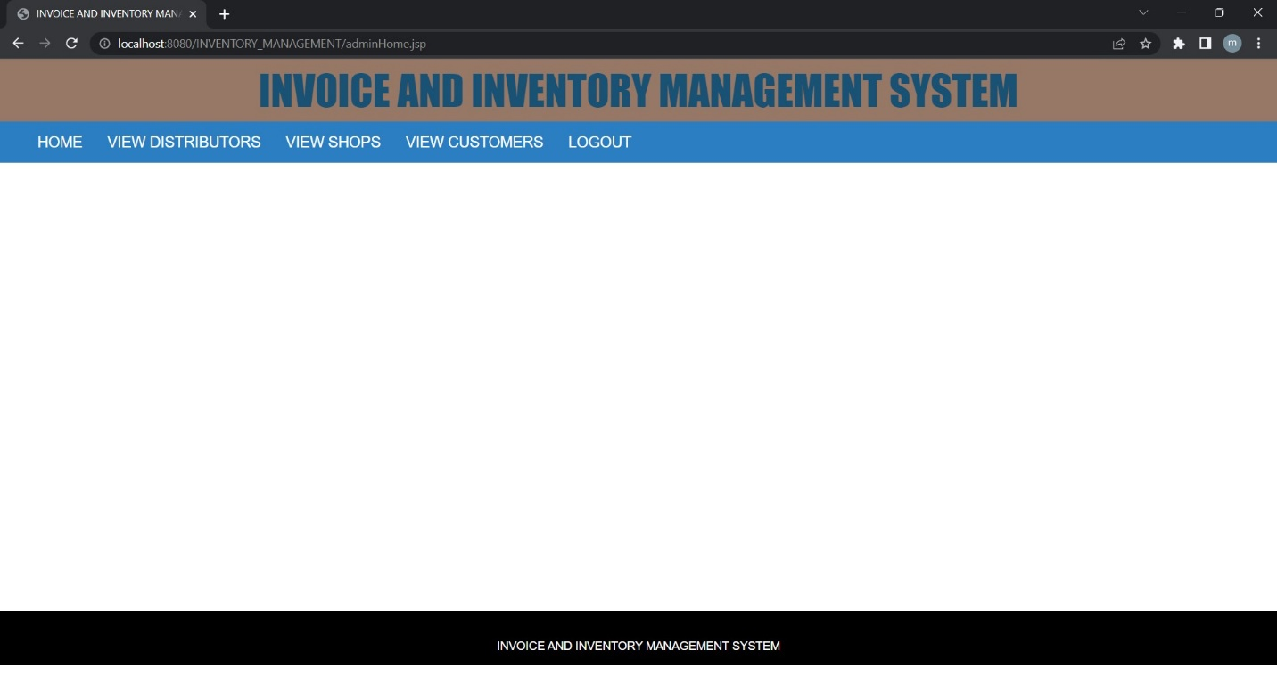

Registration page for Users – Users can create their profile by filling out the registration form.

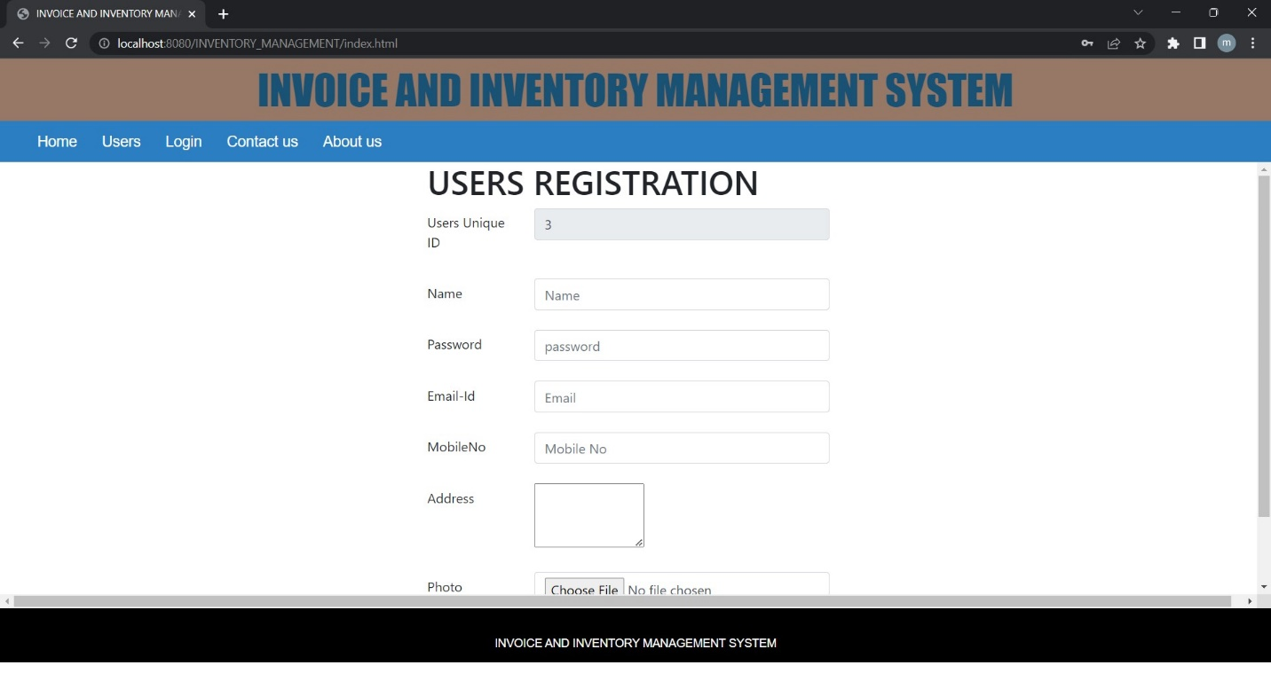

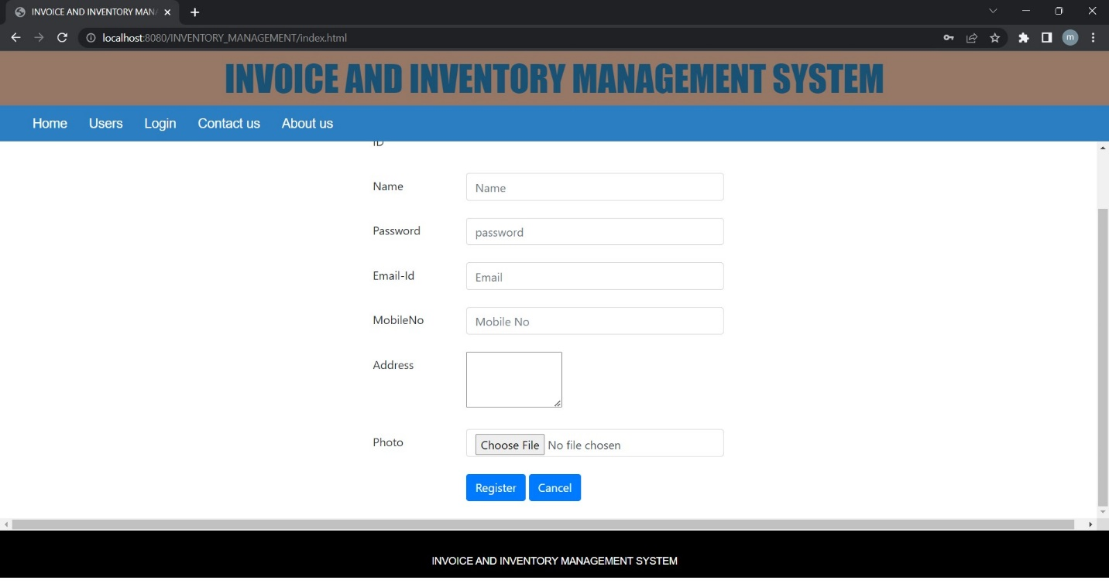

The user will not be able to log in directly with his credentials. Once the User registered successfully the request will go to the admin. To get login with the user credentials admin must accept the request of the user. To accept the request admin should log in with admin credentials. Once the request is accepted by the admin user can log in with his credentials.

After login in with user credentials we can see we have the option to view the profile, change the password, and log out functionality.

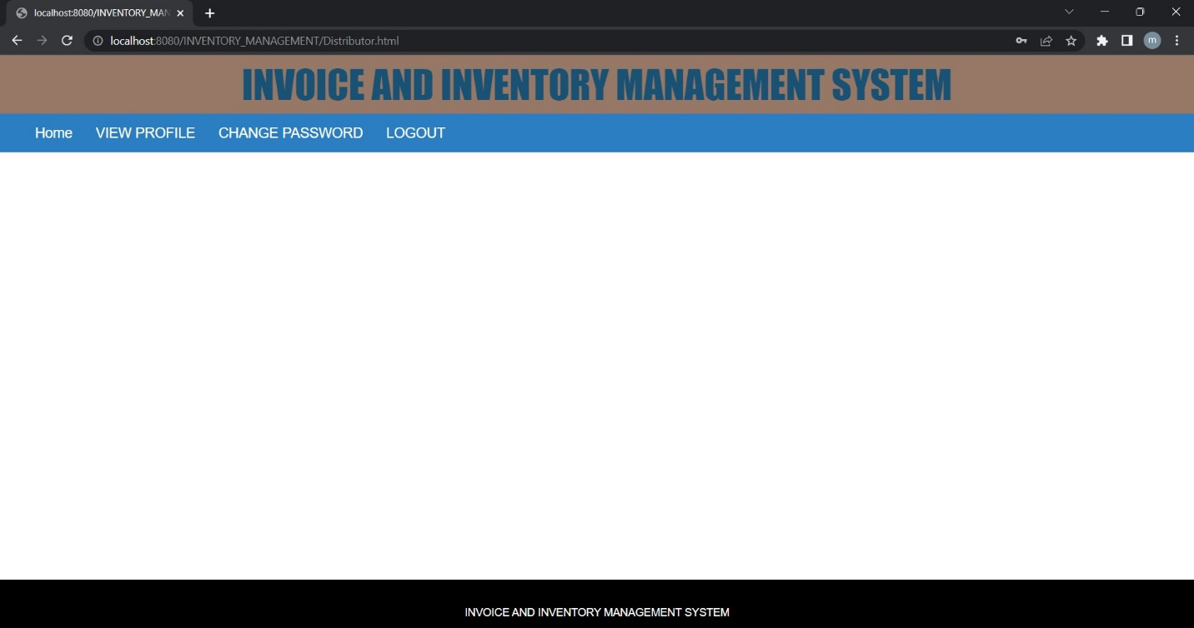

1. Project Deployment
2. Conclusion
3. Reference